Date: 17.06.2026 – 6.00 PM
Project Initialization
1. Created Project Folder Structure
Created the main project folder ProcessMind-AI with these directories:
text
ProcessMind-AI/
├── backend/
├── frontend/
├── database/
├── docs/
├── docker/
├── scripts/
├── assets/
└── README.md
2. Generated Spring Boot Project
- Used Spring Initializr to generate the project
- Configuration:
  - Project: Maven
  - Language: Java
  - Spring Boot: 3.5.15 (Latest Stable)
  - Group: com.processmind
  - Artifact: processmind-api
  - Name: ProcessMind API
  - Package: com.processmind
  - Packaging: Jar
  - Java: 21

3. Added Dependencies
Category | Dependencies
Core | Spring Web, Spring Boot DevTools, Spring Validation
Database | Spring Data JPA, PostgreSQL Driver, Flyway Migration
Security | Spring Security
Utilities | Lombok
Monitoring | Spring Boot Actuator
Documentation | SpringDoc OpenAPI

Database Setup
4. Installed PostgreSQL 17 on Windows
- Downloaded PostgreSQL 17 from EnterpriseDB
- Configuration:
  - Username: postgres
  - Password: 123
  - Port: 5432
5. Installed pgAdmin
- Came bundled with PostgreSQL
- Used to manage databases visually
6. Created Database
- Created processmind_db database in pgAdmin
- No tables created yet (managed by Flyway migrations)

Backend Structure Setup
7. Fixed Java Package Structure
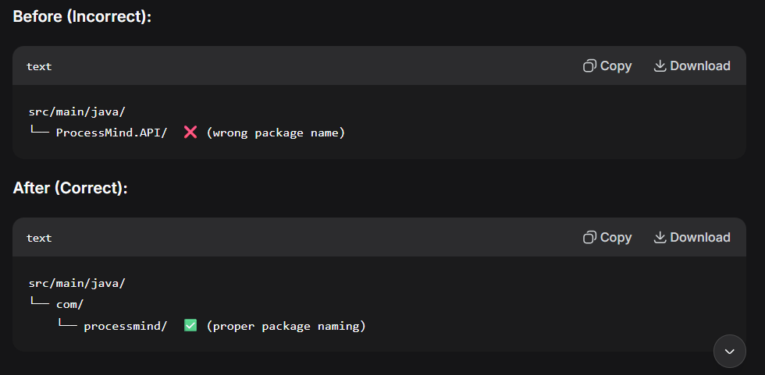
8. Created Modular Package Structure
Created the package-by-feature architecture:
text
src/main/java/com/processmind/
├── ProcessmindApiApplication.java
├── common/
│ ├── constants/
│ ├── controller/
│ ├── dto/
│ ├── enums/
│ ├── exception/
│ ├── response/
│ ├── util/
│ └── validation/
├── config/
├── security/
└── modules/
├── authentication/
├── organization/
├── user/
├── sop/
├── workflow/
├── execution/
├── analytics/
├── notification/
├── administration/
└── ai/
Each module has its own:
- controller/
- service/
- repository/
- entity/
- dto/
- mapper/
- exception/
- validator/

Configuration
9. Created Application Configuration Files
text
src/main/resources/
├── application.yml (main config, sets active profile to 'dev')
├── application-dev.yml (development environment config)
├── application-prod.yml (production environment config - created for future)
├── db/
│ └── migration/
│ └── V1__initial_schema.sql
├── static/
└── templates/

10. Configured Database Connection
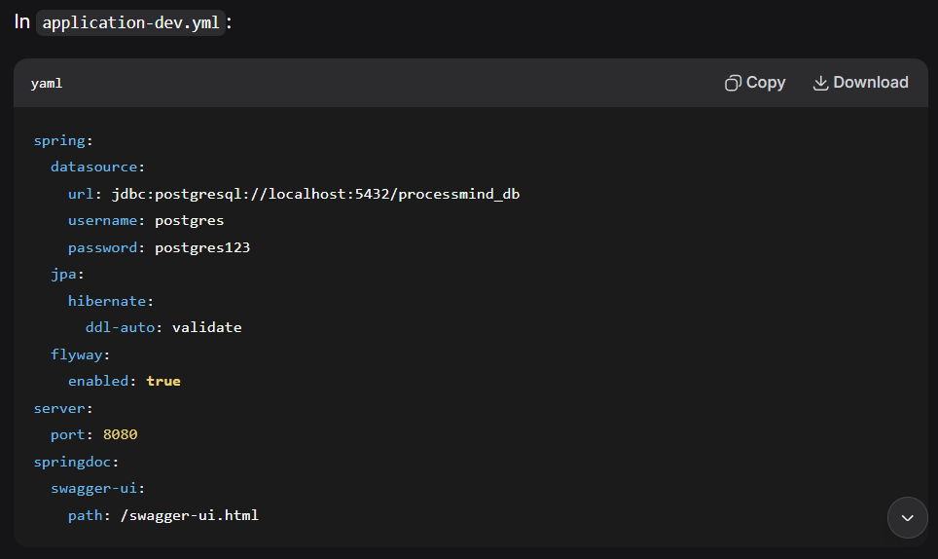
Database Migrations
11. Created First Flyway Migration
- File: V1__initial_schema.sql
- Content: CREATE SCHEMA IF NOT EXISTS processmind;
- Successfully applied when application started

API Endpoints
12. Created HealthController
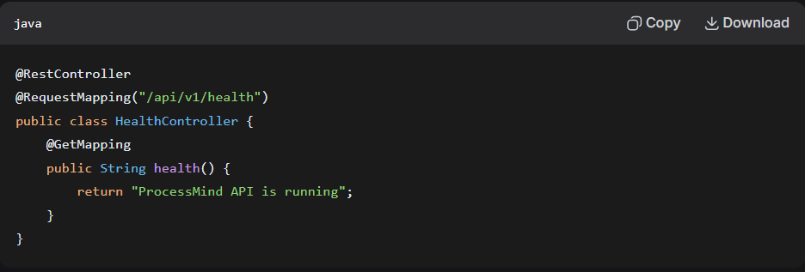
13. Created SecurityConfig
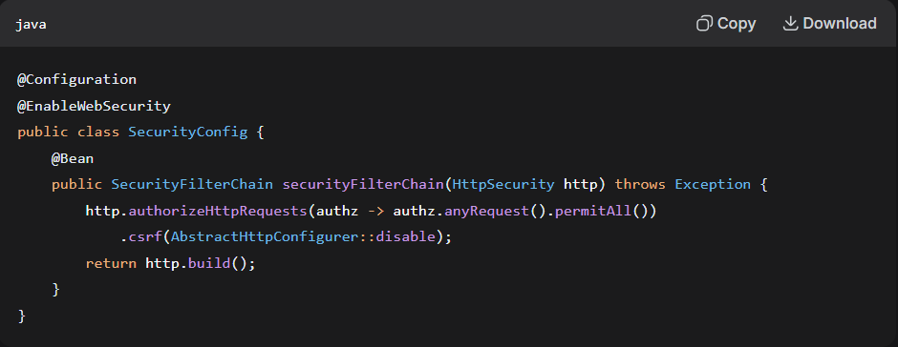
Why this was needed: Spring Security was auto-generating a login page. This config disables authentication for development.

Testing & Verification
14. Ran the Application
- Command: mvn spring-boot:run -Dspring-boot.run.profiles=dev
- Result: Application started successfully in 5.091 seconds

15. Verified All Endpoints
Endpoint | Status | Response
http://localhost:8080/api/v1/health | ✅ Working | ProcessMind API is running
http://localhost:8080/swagger-ui.html | ✅ Working | Swagger UI loads
http://localhost:8080/actuator/health | ✅ Working | {"status":"UP"}

16. Verified Database Connection
- ✅ HikariCP connection pool started
- ✅ PostgreSQL connection established
- ✅ Flyway migration applied successfully

Summary of Technologies Used
Technology | Version | Purpose
Java | 21 | Programming language
Spring Boot | 3.5.15 | Application framework
Maven | - | Build tool
PostgreSQL | 17 | Database
Flyway | 11.7.2 | Database migrations
Spring Security | - | Authentication (configured for dev)
Lombok | 1.18.46 | Boilerplate code reduction
SpringDoc OpenAPI | 2.8.16 | API documentation
JPA/Hibernate | - | ORM framework

Key Architecture Decisions
1. Package-by-Feature (Modular Monolith)
- Instead of traditional package-by-layer (controller/, service/, repository/ across the whole app)
- Each business module is self-contained
- Better scalability and maintainability
- Makes it easier to extract microservices later
2. Flyway for Database Migrations
- Version-controlled database schema
- Automatically applies migrations on startup
- Keeps all environments in sync
3. Profile-Based Configuration
- dev profile for development
- prod profile for production (to be configured)
- Environment-specific settings isolated
4. JPA with validate Mode
- Hibernate validates schema matches entities
- Does NOT auto-create/update tables
- Flyway handles schema changes instead

Commands Used Summary
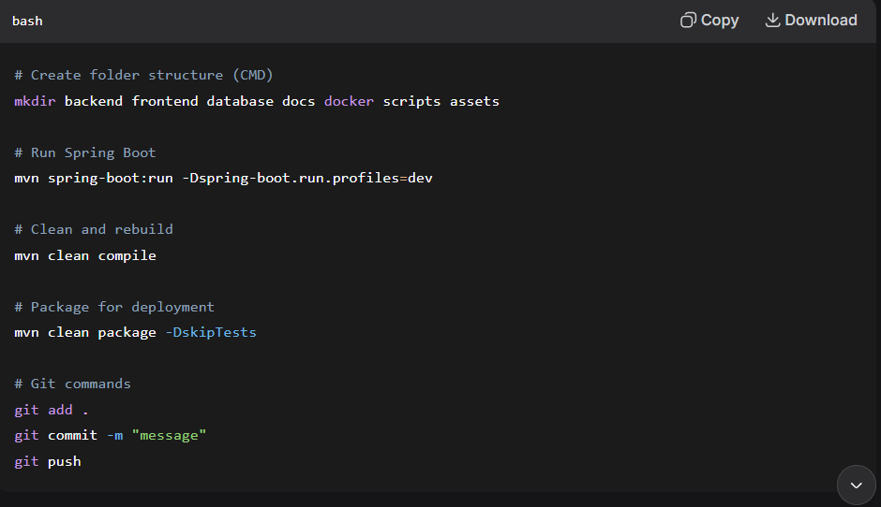

What's Working
Component | Status
✅ Project structure | Complete
✅ PostgreSQL connection | Working
✅ Flyway migrations | Applied
✅ Health check endpoint | Working
✅ Swagger UI | Working
✅ Actuator endpoint | Working
✅ Spring Security | Configured (development mode)
✅ Modular structure | Created
✅ All 10 modules | Stubbed out

